Microsoft Excel

**ROW COLUMN**

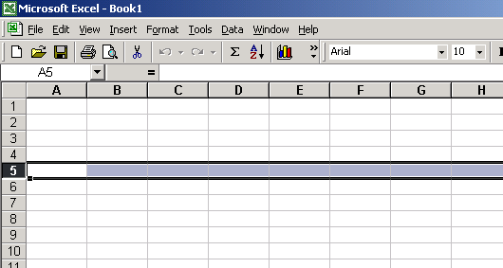 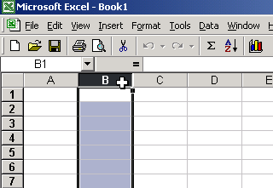

**CELL AUTO FILL**

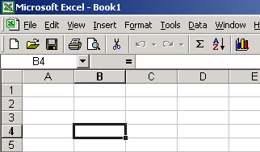 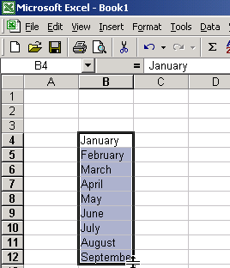

**AUTOSUM** 

This button can add many numbers in a row or many numbers in a column

**FORMULA BAR** This is where you make changes to what is in the cell. 